**Project Description**

**SQL PROJECT- MUSIC STORE DATA ANALYSIS**

**Please find below the steps to work on the music store project**.

Start by creating all the required tables with the required constraints which will help you to create the relationship between the tables. Make sure to derive the required constraints you make use of the schema diagram from the project folder. Below you will find the hints and help required to create all the tables.

**👉 Kindly click on the** [**Dataset**](https://drive.google.com/drive/folders/1EMdXOZTzYhGacnQkhwh8hcF_Bd8WATy0?usp=share_link) **to check and download**

**1.** **Employee table.**

**a.** Create all the columns with the required data types

**b.** Make “employee_id” as the primary key for this table.

**2.** **Customer Table.**

**a.** Create all the columns from the customer table

**b.** Make “customer_id” as the primary key.

**c.** Make “support_reo_id” as foreign key which is referencing “employee_id” from the **employee table** and make sure you are using cascade and not null actions while creating foreign keys.

**3.** **Invoice table**.

**a.** Create all the required columns in the invoice table.

**b.** Make ‘’invoice_id” as the primary key.

**c.** Make “customer_id” as foreign key referencing the “customer_Id” from the **customer table** and make sure you are using cascade and not null actions while creating foreign keys.

**4.** **Invoice_line.**

**a.** Create all the required columns in the invoice line table.

**b.** Make “invoice_line_id” as the primary key.

**c.** Make “invoice_id” as the foreign key which is referencing the “invoice_id” from the **invoice table** and make sure you are using cascade and not null actions while creating foreign keys.

**d.** Also all foreign key constraints to the “track_id” referencing the “track_id” from the **track** table.

**5.** **Track table.**

**a.** Create all the required columns from the track table.

**b.** Make “track_id” as the primary key.

**c.** Make “media_type_id” as the foreign key referencing the “media_type_id” columns from the table **“Media_type”** and make sure you are using cascade and not null actions while creating foreign keys.

**d.** Make “genre_id” as foreign key referencing the “genre_id” from the **Genre table** and make sure you are using cascade and not null actions while creating foreign keys.

**e.** Make “album_id” as foreign key referencing the “album_id” from the **album table** and make sure you are using cascade and not null actions while creating foreign keys.

**6.** **Playlist table.**

**a.** Create all the required columns.

**b.** Make “playlist_id” as the primary key.

**7.** **Playlist_track.**

**a.** Create all the required columns.

**b.** Make “playlist_id” as foreign key referencing the “playlist_id” from the **Playlist table** and make sure you are using cascade and not null actions while creating foreign keys.

**c.** Make “track_id” as foreign key referencing the “track_id” from the **track table** and make sure you are using cascade and not null actions while creating foreign keys.

**8.** **Media_type table.**

**a.** Create all the required columns.

**b.** Make “media_type_id” as the primary key.

**9.** **Genre table.**

**a.** Create all the required columns.

**b.** Make “genre_id” as the primary key.

**10.** **Album table.**

**a.** Create all the required columns.

**b.** Make “album_id” as the primary key

**c.** Make “artist_id” as the foreign key referencing the “artist_id” from the **artist table** and make sure you are using cascade and not null actions while creating foreign keys.

**11.** **Artist table.**

**a.** Create all the required columns.

**b.** Make “artist_id” as the primary key.

Once you are done creating all the required tables start importing the data from the files provided into the respective tables .

You can make use of the below shared steps to insert the data into the tables where it has shared the example to store data into the customer table which was already created.

(**Note: if you are directly importing the tables into Mysql relationships between the tables will not be defined and you will not be able to create schemas by reverse engineering.)**

· Click on the schema on the right hand side and do a right click on the customer table and click on the **Table data import wizard.**

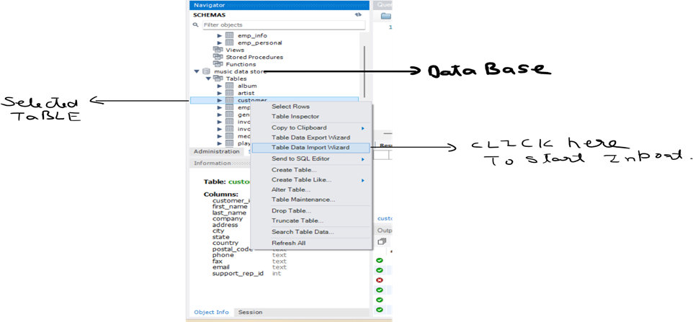

· Select the required file from your device and click on next.

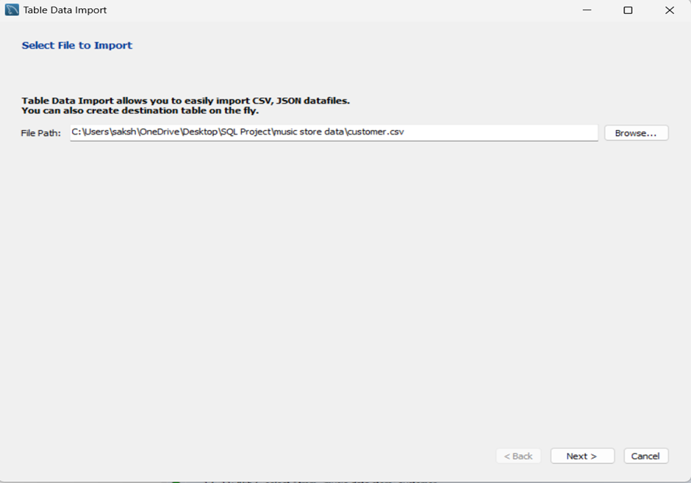

· Click on the **Use existing table** on the screen so that the data is inserted in the table which you have already created.

(**Note: if you are selecting to create new table then the previously created table will be dropped and this will affect the relationship between the tables.)**

· Click on next to go to the next step.

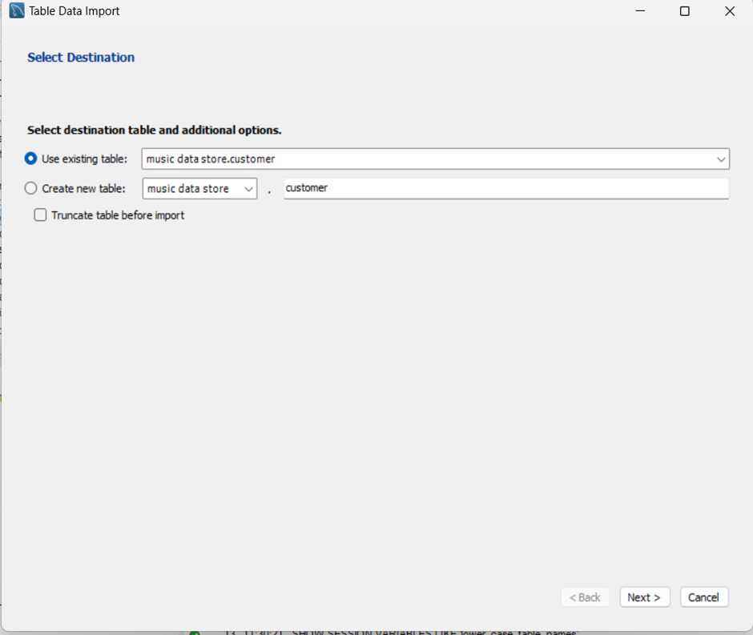

· In this step we will get the source columns from where the data is coming from and the destination columns which are columns in the table we have created.

· If in case you find any discrepancies you are free to change the columns just make sure we are inserting data into correct columns.

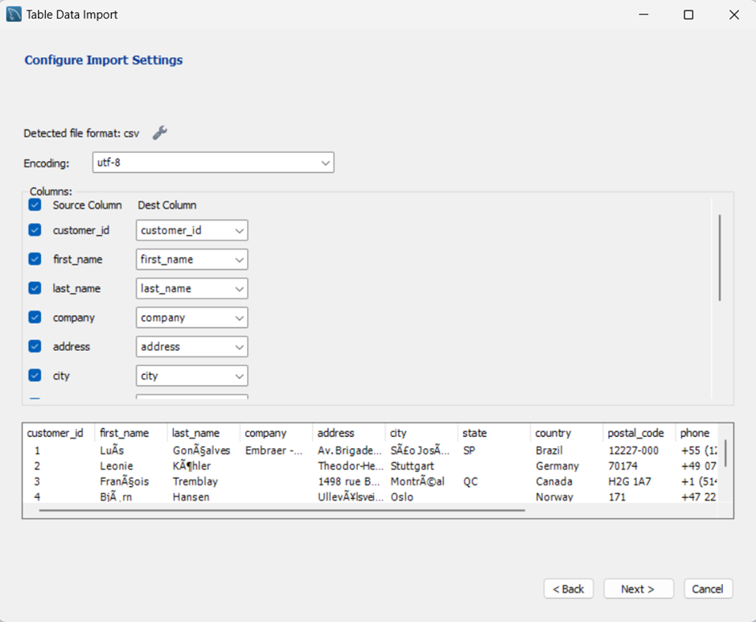

· Click on next to execute this step.

· Again, click on next to start the import and then click on finish.

**Major Task**

**Question Set 1 - Easy**

* Who is the senior most employee based on job title?
* Which countries have the most Invoices?
* What are top 3 values of total invoice?
* Which city has the best customers? We would like to throw a promotional Music Festival in the city we made the most money. Write a query that returns one city that has the highest sum of invoice totals. Return both the city name & sum of all invoice totals
* Who is the best customer? The customer who has spent the most money will be declared the best customer. Write a query that returns the person who has spent the most money

**Question Set 2 – Moderate**

* Write query to return the email, first name, last name, & Genre of all Rock Music listeners. Return your list ordered alphabetically by email starting with A
* Let's invite the artists who have written the most rock music in our dataset. Write a query that returns the Artist name and total track count of the top 10 rock bands
* Return all the track names that have a song length longer than the average song length. Return the Name and Milliseconds for each track. Order by the song length with the longest songs listed first

**Question Set 3 – Advance**

* Find how much amount spent by each customer on artists? Write a query to return customer name, artist name and total spent
* We want to find out the most popular music Genre for each country. We determine the most popular genre as the genre with the highest amount of purchases. Write a query that returns each country along with the top Genre. For countries where the maximum number of purchases is shared return all Genres
* Write a query that determines the customer that has spent the most on music for each country. Write a query that returns the country along with the top customer and how much they spent. For countries where the top amount spent is shared, provide all customers who spent this amount

